Restricted Boltzmann machine

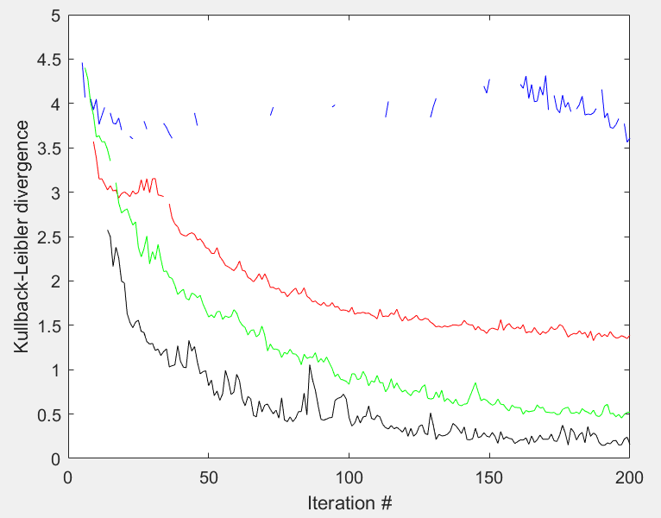The figure to the right shows the KL-divergence for the **two**, **four**, **eight**, and **sixteen** hidden neuron cases.

To estimate the Boltzmann distributions, I sampled 20k randomly generated patterns.

For a sample pattern, where the 2nd column is -1 and the other values are 0, the first 10 iterations are shown below. The network converges to a stored pattern in the 1st iteration, but due to the stochasticity made an error in the 3rd iteration which was not corrected until the 5th.

|  |  |  |  |  |  |  |  |  |  |  |  |  |  |  |  |  |  |  |
| --- | --- | --- | --- | --- | --- | --- | --- | --- | --- | --- | --- | --- | --- | --- | --- | --- | --- | --- |
|  |  |  |  |  |  |  |  |  |  |  |  |  |  |  |  |  |  |  |
|  |  |  |  |  |  |  |  |  |  |  |  |  |  |  |  |  |  |  |
|  |  |  |  |  |  |  |  |  |  |  |  |  |  |  |  |  |  |  |
|  |  |  |  |  |  |  |  |  |  |  |  |  |  |  |  |  |  |  |
|  |  |  |  |  |  |  |  |  |  |  |  |  |  |  |  |  |  |  |
|  |  |  |  |  |  |  |  |  |  |  |  |  |  |  |  |  |  |  |
|  |  |  |  |  |  |  |  |  |  |  |  |  |  |  |  |  |  |  |